**COMSATS UNIVERSITY ISLAMABAD**

**ATTOCK CAMPUS**



**NAME:** Abbas Khan | Ahsan khan

**REGISTRATION NUMBERS:** SP22-BSE-020 | SP22-BSE-016

**SUBJECT:** Human Computer Interaction

**DATE:** 26th March 2025

**Fitts’ Law Analysis**

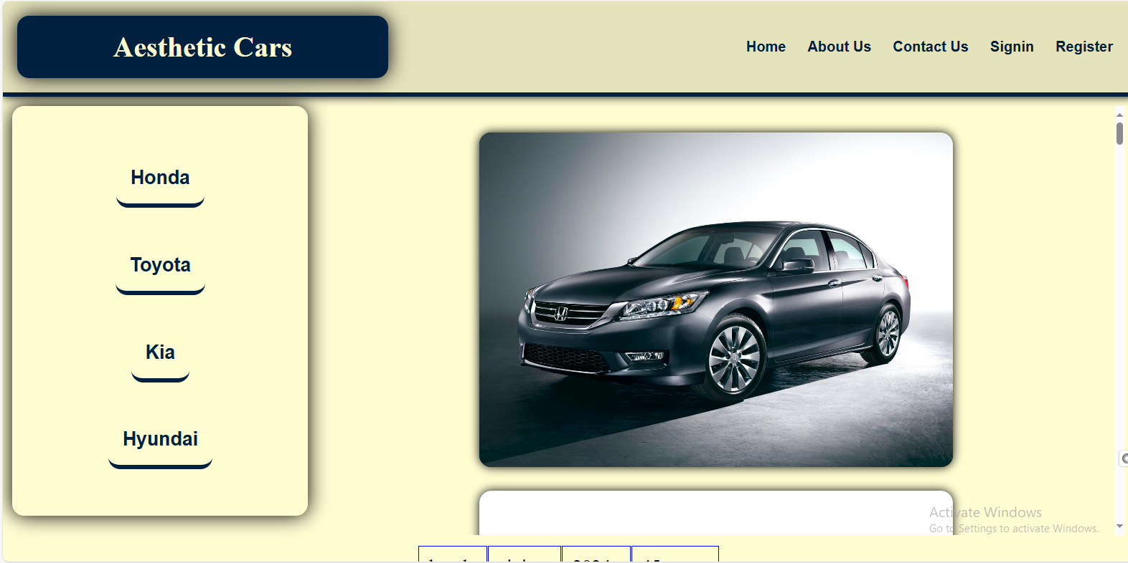

**1. Target Size and Spacing**

* **Vertical Brand Navigation (Honda, Toyota, Kia, Hyundai):**  
  Each brand name is contained within a rounded or rectangular box. While the clickable area appears somewhat large, there is a moderate gap between them. If these elements are close in size or smaller than a typical fingertip (for mobile/touch users), they might be slightly difficult to select.
* **Top Navigation (Home, About Us, Contact Us, Sign In, Register):**  
  These links are horizontally spaced. The text size and padding around each link influence how quickly and accurately users can click or tap. If the text and its clickable area are small, it could lead to selection errors—especially on mobile.
* **Main Car Image:**  
  If the car image is clickable (e.g., leading to a detail page), its size makes it an easy target. If it’s just a decorative image, it’s fine as is, but consider whether it should be interactive if it provides additional detail.

**2. Distance to Interactive Elements**

* **Brand Navigation Placement:**  
  Placed on the left side, the brand buttons require lateral movement from the main content area. Users focusing on the central image or text have to shift their pointer or tap target to the far left to interact with brand links.
* **Top Navigation Placement:**  
  Positioned at the top, the menu is in a conventional place, which is generally good for desktop usage. However, on mobile devices or smaller screens, users might have to scroll back to the top to access it if the layout isn’t responsive or if the site uses a fixed (non-sticky) header.

**3. Screen Edges and Corners**

* **Top Corners:**  
  The corners of the screen are prime real estate, as per Fitts’ Law, because users can quickly “slam” the mouse pointer or their finger into a corner. Currently, it looks like the site’s logo is in the top-left corner and the navigation is near the top-right. This is a standard approach but consider whether additional or critical calls-to-action (CTAs) could be placed near these edges for easier access.
* **Left Edge for Brand Menu:**  
  The left edge is used for brand selection. This is typically fine, but consider making the clickable area more prominent or sticky so that users can switch brands without needing to scroll excessively.

**4. Visual Hierarchy and Feedback**

* **Hover/Active States:**  
  If the site lacks hover or active states on the navigation links or brand buttons, users may not immediately realize they are clickable. Clear feedback helps reduce selection time because it confirms the target is interactive.
* **Button vs. Text Links:**  
  If brand names are simply text within a shape (rather than actual buttons), the clickable region might not be clear. Making them appear more “button-like” could help users acquire the target more quickly.

**Enhancement Suggestions (Fitts’ Law in Practice)**

1. **Enlarge Clickable Areas**
   * Increase the padding or bounding box for the brand buttons on the left so they’re more finger-friendly on mobile devices.
   * Ensure the text links in the top navigation have sufficient padding to be easily clickable, even on smaller screens.
2. **Optimize Spacing**
   * If the vertical brand list is too close together, add a bit more space to avoid accidental clicks. This is particularly important if some users browse via touchscreen.
   * Similarly, consider grouping related items (e.g., “Sign In” and “Register” together) with consistent spacing to reduce cognitive load.
3. **Consider Sticky or Responsive Navigation**
   * A sticky (fixed) top bar means the navigation remains visible even when the user scrolls down. This reduces the distance to key links like “Sign In” or “Contact Us,” aligning with Fitts’ Law by bringing interactive targets closer.
4. **Leverage Screen Edges**
   * Keep important CTAs or frequently accessed links near the corners or edges. If “Register” is a key action, consider placing it more prominently in the top-right corner (or a similarly high-visibility location).
5. **Provide Clear Visual Feedback**
   * Implement hover states, pressed states, or color changes for the brand buttons and the top navigation links. When a user hovers over or taps a link, it should clearly indicate “this is clickable.”
   * Consider slightly enlarging or highlighting the brand button on hover/tap to make the selection process feel more intuitive.
6. **Ensure Mobile-Friendliness**
   * Test the site on multiple device sizes to confirm that text and button sizes meet recommended minimums (around 44x44 points for tap targets, per Apple/Google guidelines).
   * Check that brand links on the left don’t become too cramped or disappear on smaller screens. A collapsible menu or responsive layout can keep targets large and easy to tap.
7. **Use Larger Buttons for Primary Actions**
   * If you have calls-to-action (like “Book a Test Drive,” “Contact Dealer,” etc.), consider making them prominent, large, and easy to reach. Placing them at or near the center or corners can reduce pointer travel time.

**Calculations:**

